Pokhara University

Level: Bachelor | Semester – Spring | Year : 2006
Programme: BE |  | Full Marks: 100
Course: Electronic Circuit I |  | Time : 3hrs.

Candidates are required to give their answers in their own words as far as practicable.
The figures in the margin indicate full marks.

Attempt all the questions.

 | - While cascading, common base configuration cannot be used in intermediate stages although it has high voltage gain. Why? Explain.  - Why cascading is necessary? The two transistors are cascaded where the unloaded voltage gain of 1st and 2nd stages are 24 dB and 20 dB respectively. The input resistance of 1st stage and 2nd stages are 8 KΩ and 20 KΩ respectively. Similarly the output resistances are 4 KΩ and 2 KΩ respectively. The 1st stage is driven by a source having resistance of 10 KΩ and 20 Ω load resistance is connected across the output terminal of 2nd stage. Find V_{L} / V_{S.}  - The self bias circuit (Voltage divider) is given below.  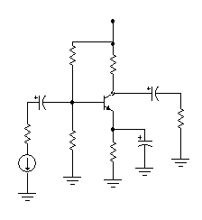  +V_{CC}  R₁  R_{c}  C₁  C₂  R_{L}  r_{s}  R₂  R_{E}  C_{E}  V_{S}  What are the main purposes of C₁, C₂ and C_{E}? | 5  1+4  5
 | - Draw gain versus frequency plot for voltage divider (CE) circuit. Briefly, explain why gain is low at higher frequencies.  - Find the value of lower cut off frequency for the circuit given below.  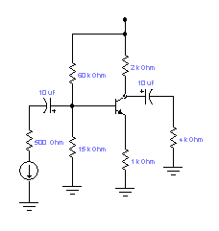  +20V  V_{S}  Given β = 100, neglect r_{e} and r_{c}  4 KOhm  2 KOhm  - For the given circuit, briefly explain its operation. Draw its output waveform.  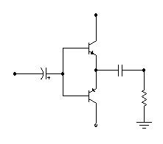  t  V_{in}  +V_{cc}  V in  V out  R_{L}  -V_{cc} | 5  5  5
 | - What do you mean by power amplifier? Differentiate between class A and class B power amplifier?  - “Negative feedback reduces gain, but it is used in amplifier." Justify it.  - With the help of equivalent circuit diagram, derive the expression for input impedance of current series feedback configuration. | 1+4  5  5
 | - Why positive feedback is used in oscillator? Draw Hartley oscillator circuit and explain its operation.  - Draw RC phase shift oscillator circuit and explain how Barkhusen criteria are applied to find out its frequency of oscillation. | 7  3+5
 | - Draw simple subtractor circuit and derive its output voltage. (use Op-Amp).  - Draw Schmitt trigger circuit. Explain its operation. Draw necessary waveforms.  - Design operational Amplifier circuit to produce the following output:  Vo = 5V₁+0.5V₂  Where V₁ and V₂ are the inputs  OR  - For the circuit given below, find its dc equivalent, ac equivalent, equivalent r_{e} model and its input resistance (r_{in stage}). (Given β = 100)  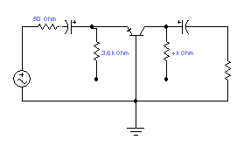  -8V  +10V  r_{in} _{stage}  - Define lower and upper cut off frequency. "Cut off frequencies are also called 3-dB frequency" justify it.  - Transformer coupled load class A-amplifier has higher efficiency than that of direct coupled load class A amplifier. Explain why? | 5  5  5  5  5  5
 | - Explain how R-2R ladder DAC minimizes the drawbacks of binary weighted resistor DAC? Draw R-2R ladder network for D/A conversion and explain its operation.  - Draw Flash type ADC. Explain its operation. What are its advantages and disadvantages?  OR  - Between bridge rectifier and center tap rectifier, which one you would prefer for rectification and why? Draw full wave Bridge rectifier and explain its operation.  - Why regulation is necessary? Explain load regulation. Draw transistor series regulator circuit and explain its operation. | 2+5  3+3+2  3+4  2+2+4
 | Write short notes on (Any Two):  - Effect of negative feedback on bandwidth  - Darlington pair amplifier and its effective β  - Shunt capacitor filter | 5×2

